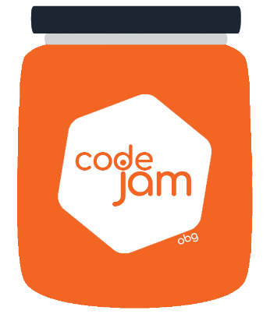

Challenge 4: Animate

All went well with the last effort and the dog looks amazing, commercial and UI/UX department is delighted and you are good to go and relax. PO is happy and ready to leave in peace and all seems to be ok. There at the most crucial moment your OCD kick’s in and demands time sacrifice. It doesn’t really look like a dog if it doesn’t move. It doesn’t really look like a dog if it doesn’t blink…. ok this need to be fixes ASAP or else you are not going to sleep tonight…. Or any other night.

What you need to do:

1. Time to complete is 30min
2. Each team member has 10min to code.
3. The rest of the team can assist without coding (helping, giving ideas).
4. The animations can be done with css/js or a combination of both
5. No extra library can be used (vanilla css/ vanilla js)
6. Be fully creating and imaging the best effect to add to your dog, there are no limitations except the box boundaries we have assigned (inside the main-section area).